**Assignment 3**

**Name**: Preethika P

**Roll No**: 718019Z230

**Team ID**: PNT2022TMID12507

**Project**: News Tracker Application

**1. IBM Cloud Object Storage**

**news.html**

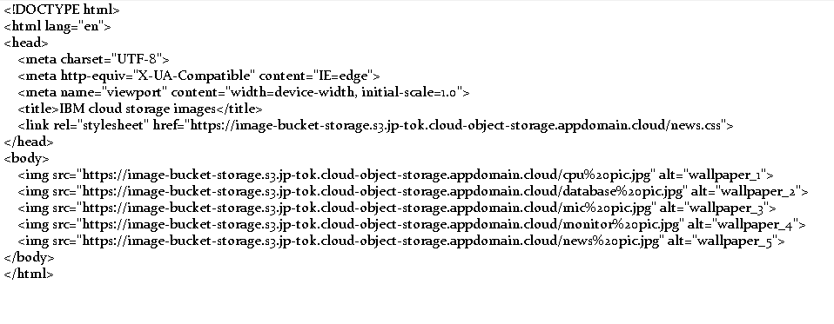

**image.css:**

html{

background-color: rgb(43, 43, 43);

}

body {

display: flex;

flex-wrap: wrap;

gap: 100px;

justify-content: center;

align-items: center;

}

img {

width: 25%;

}

**Screenshot:**



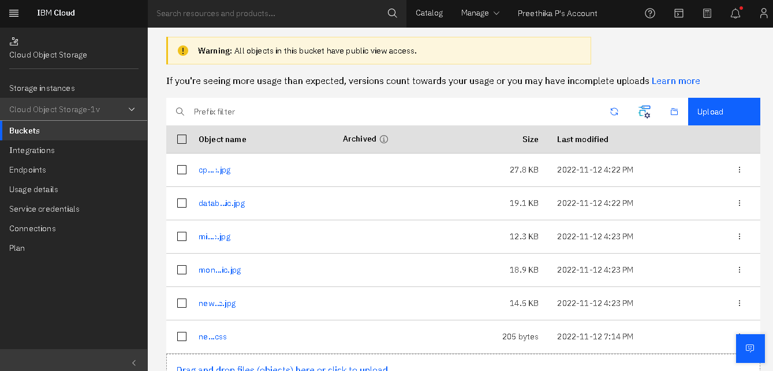

**2. IBM Watson chatbot Chatbot Link:**

https://webchat.global.assistant.watson.appdomain.cloud/preview.html?integrationID=e1ea58ee-e2c7-4de1-8228-04c18ed27b95&region=au-syd&serviceInstanceID=3ca7f743-b7d2-4c66-a3d0-77794af569ce

**screenshot:**

